Developed API end-points:

* **Get Recipes:** curl --location 'localhost:3000/api/recipes/recipe-repo'

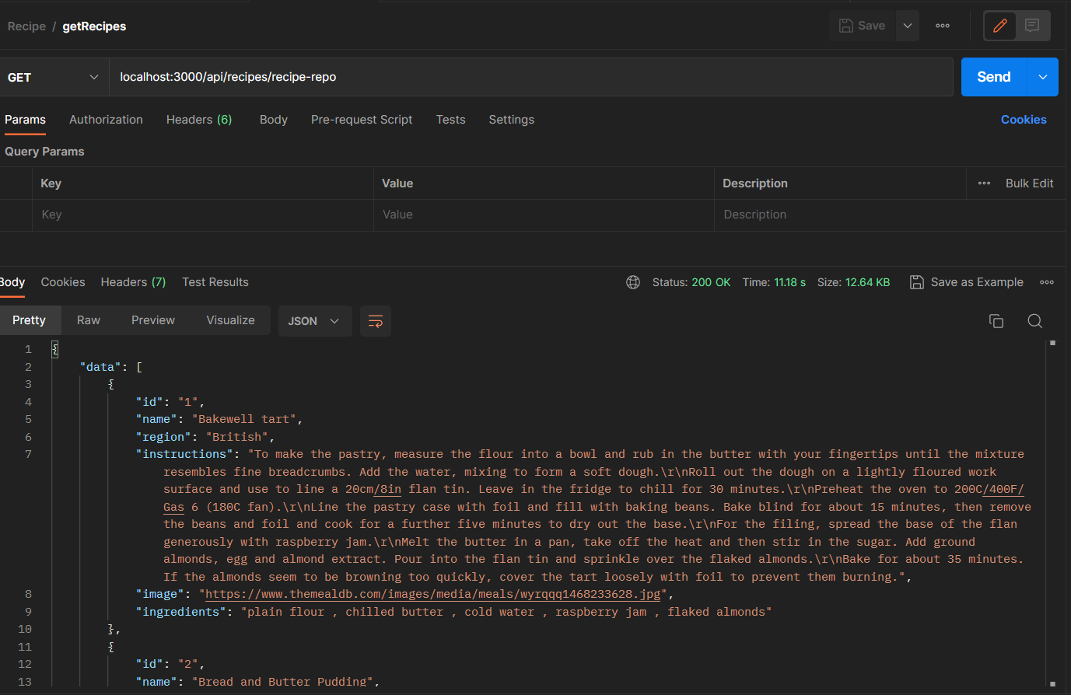

* **Get Recipes with id:** curl --location 'localhost:3000/api/recipes/recipe-repo?id=8'

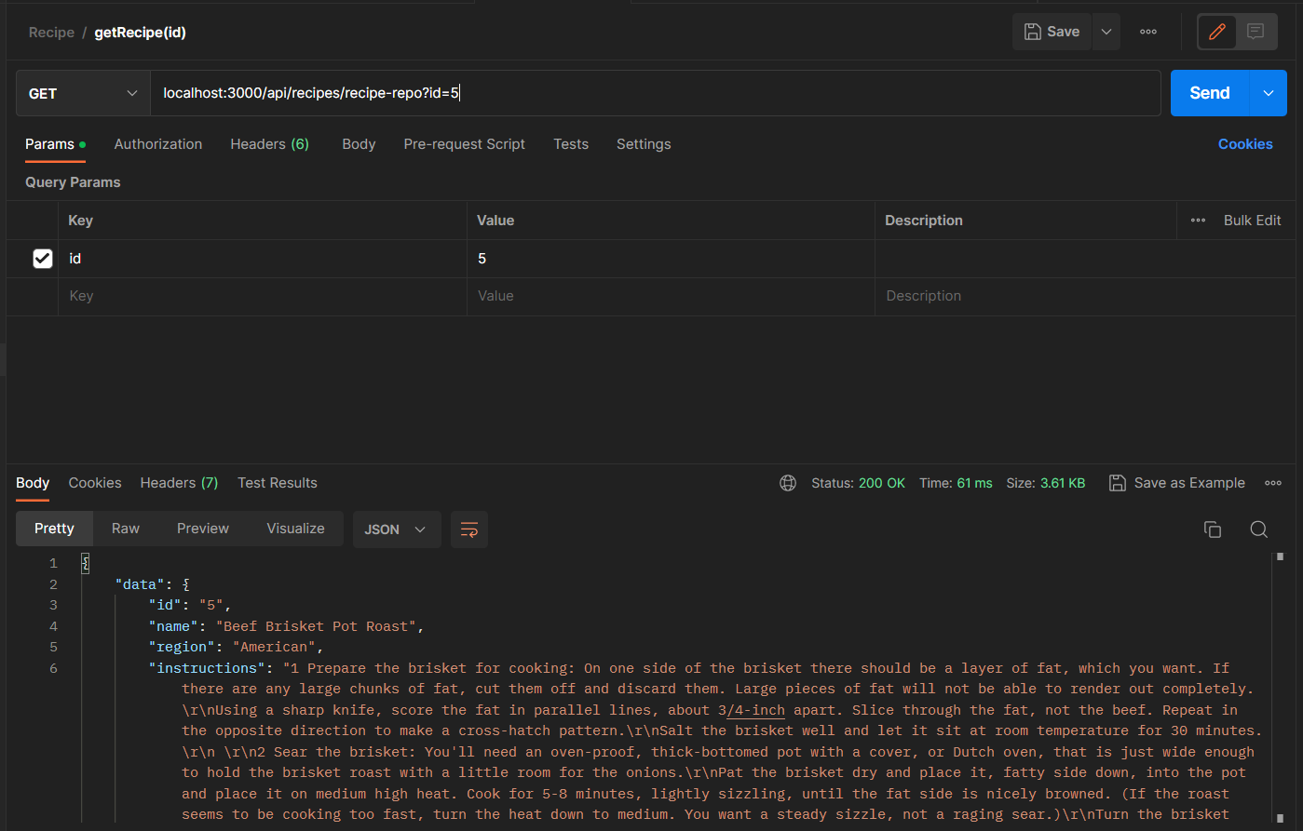

* **Get Recipes with region:** curl --location 'localhost:3000/api/recipes/recipe-repo?region=British'

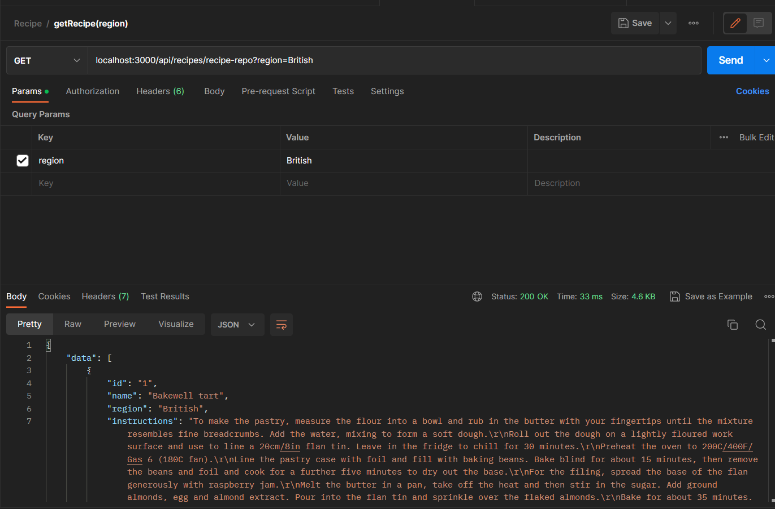

* **Add Recipe:**

curl --location 'localhost:3000/api/recipes/recipe-repo' \

--header 'Content-Type: application/json' \

--data '{

"name": "Test name",

"region": "test region",

"instructions": "test instruction.",

"image": "https://www.themealdb.com/images/media/meals/wyrqqq1468233628.jpg",

"ingredients": "plain flour , chilled butter , cold water , raspberry jam , flaked almonds"

}'

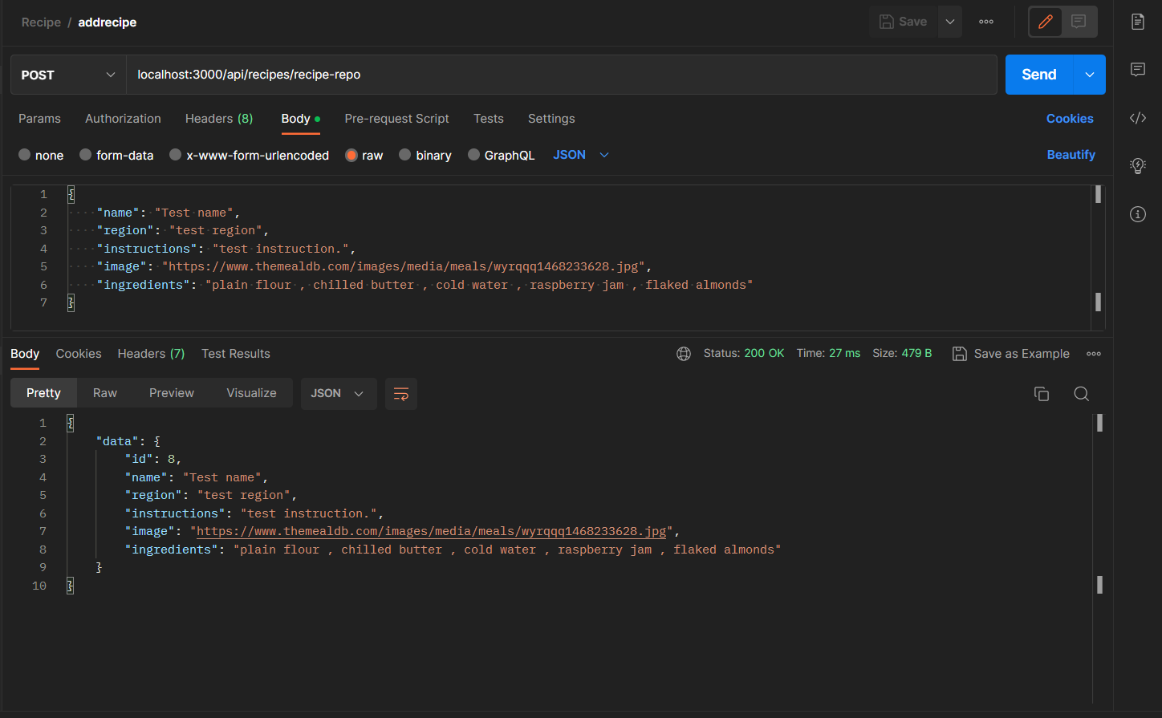

* **Update recipe:**

curl --location --request PUT 'localhost:3000/api/recipes/recipe-repo?id=8' \

--header 'Content-Type: application/json' \

--data '{

"name": "abcd",

"region": "region",

"instructions": "Instructions.",

"image": "https://www.themealdb.com/images/media/meals/wyrqqq1468233628.jpg",

"ingredients": "plain flour , chilled butter , cold water , raspberry jam , flaked almonds"

}'

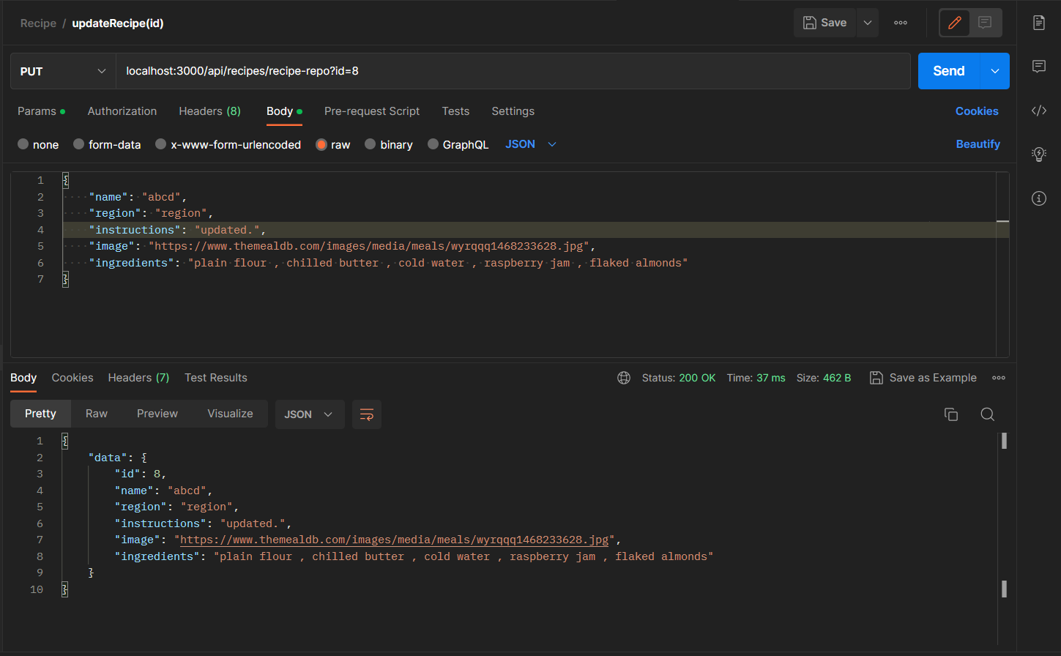

* **Delete Recipe:** curl --location --request DELETE 'localhost:3000/api/recipes/recipe-repo?id=8'

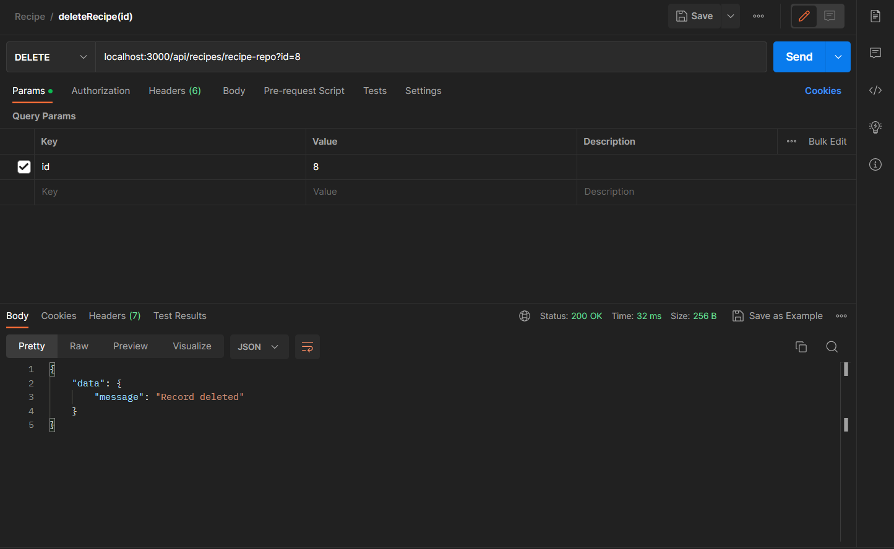

Pre-requisite:

* Install node modules by running following command

Npm i

If you still need any changes let me know.

Please leave 5-star rating and detailed nice feedback as it matters a lot for me😊